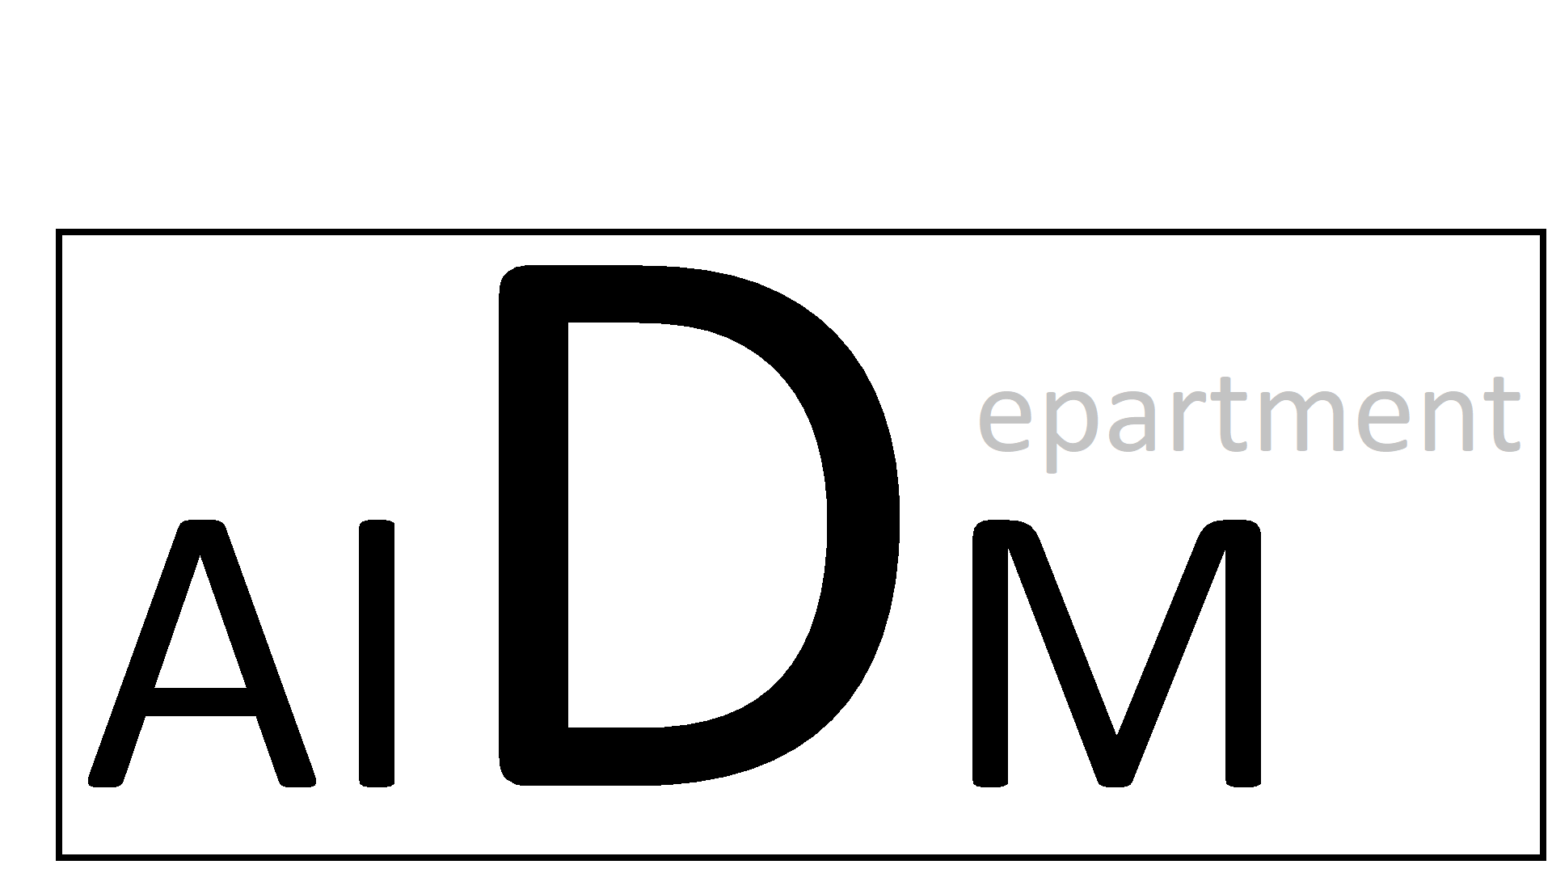

**Y1A 2021**

Project Brief

Academic year: 2021-2022

Educational year: Year 1

Block: Block A

Credits: 15 ECTS

Osiris Code:

Last update:

Contact:

Contents

1. Project Brief 3

1.1 Brief Outline 3

1.2 Project Kick-Off 3

1.3 Block- and week structure 3

1.4 Dates 3

1.5 Competency Profile and Dublin descriptors 4

1.6 Learning Outcomes 5

1.7 (Formative) feedback 6

1.8 Summative feedback 7

1.9 Retake procedure 7

2. Creative Brief I - Report on AI in Science Fiction 8

2.1 Timeline 8

Week 1 8

Week 2 8

2.2 Assignment 8

2.3 Requirements 9

2.5 Deliverable(s) 10

2.6 Required literature 10

3. Creative Brief II – Poster: Our world in data 11

3.1 Timeline 11

Week 3 11

Week 4 11

Week 5 11

3.2 Assignment: Poster-Our world in data 12

3.3 Challenges 13

3.4 Requirements 13

3.5 Deliverable(s) 13

4. Creative Brief III – Image Steganography using Python 15

4.1 Timeline 15

Week 6 15

Week 7 15

Week 8 15

4.2 Assignment 15

4.3 Challenges 16

4.4 Requirements 16

4.5 Deliverable(s) 17

# Project Brief

A creative brief is like an open invitation. It invites an individual to propose their own creative vision while still giving a clear direction on the desired outcomes. It is quite customary in the data science industry for projects to have abstract requirements. A typical example being “Can we improve our existing business processes using data?”

Similarly, our creative briefs set out to align with specific learning goals. The requirements set in the brief below will lead junior data scientists to learn about different topics, while still allowing for creative freedom in proposing and implementing a solution. Select an approach that best fits your personal learning goals, investigate the requirements, and amaze us with your creative problem solving!

In the current block the project brief contains three different creative briefs: one on digital transformation and Artificial Intelligence (two weeks project), one on data science (three weeks project) and one on programming (two weeks project). This approach gives you the opportunity to get used to our teaching philosophy and presents three hills to climb instead of a huge mountain. Furthermore, it helps you to learn the fundamentals of the program's four major focus areas. From block B on projects will span the whole block (and in later years probably more block periods). In the initial stage of the programme, all projects are done individually, in block D of the first year we introduce group work.

## Brief Outline

In this project, you will be exploring the *lifecycle of a data science project* by implementing in practice, the concepts you have learned in the workshops. You will be provided with a Github repository where you are expected to document the process of forming your idea, as well as the evolution of the solution.  The project consists of three sub-projects, the first one related to Digital Transformation and Artificial Intelligence, the second one to Data Science and the final one to Programming.

## Project Kick-Off

In the first week of the project, you will have time to meet with each of the lecturers, who will each take time to discuss and direct one aspect of the project. The aim in this time is to provide a strong, solid foundation for the rest of the project – so pay attention carefully to the feedback and direction given and execute it as efficiently and accurately as you can. This period of work is not covered by the assessment but will heavily affect how easy it is for you to work towards the assessment later.

## Block- and week structure

Within the AI&DM training a year is divided into four block periods of 10 weeks. The first eight are Lab-weeks, the final two are for assessment. In these final weeks, next to preparation of the final assessments, students can work on retakes and preparation of the next blocks. Moreover, they are encouraged to participate in extra-curricular activities, like Hackatons, competitions, etc.

Each of the Lab-weeks has a fixed structure as well: on Monday, Wednesday and Thursday students work individually on the development of their basic skills, which are needed to execute the DataLab assignments. Direction is given by the Learning Management System in Github. Each of the weeks focusses on a certain area:

Week 1-2: Digital Transformation & Artificial Intelligence

Week 3-5: Data Science

Week 6-8: Programming.

On Tuesday and Friday students work on their projects in DataLab. Each of these Lab days is finished by a formative feedback session.

Students keep track of their learning activities in a Worklog (focusing on activities) and a Learning Log (focusing on progress) In the final weeks of a block all documentation is assessed and students hear whether they fail or pass the block.

## Dates

* The project commences on **9am Monday 6th September.**
* The deadline for submission of student work is **5pm Friday 5th November (week 8).**
* Assessment will take place from **Monday 8th November** to **Friday 12th November** and grades should be published from **1pm Tuesday 15th November**.

Classes will be scheduled **on your Lab days** from **9am**, in direct relation to the learning topics covered in this project.

## Competency Profile and Dublin descriptors

An elaboration on teaching philosophy and intended learning outcomes of the Creative Media & Games Technology programme is available in the student handbook. It is advised to take notice of that document first. The learning outcomes of the AAI&DM program are described in a so-called [Creative Technologies competency profile](https://www.creativetechnologies.nl/), consisting of technological, design, organizing and professional competencies. Each block focusses on a selection of competences (connected to one of the production stages Concepting, Pre-production, Production and Delivery), which are always communicated clearly in the project brief. These are important to be aware of for students, since these are the ones that will be assessed. Furthermore, in each block professional competencies are evaluated.

One of the aims of the AAI&DM program is to consistently teach students to apply a systematic data science project management approach. We have chosen for CRISP as a methodology (In Data Science workshops the concept will be explained).

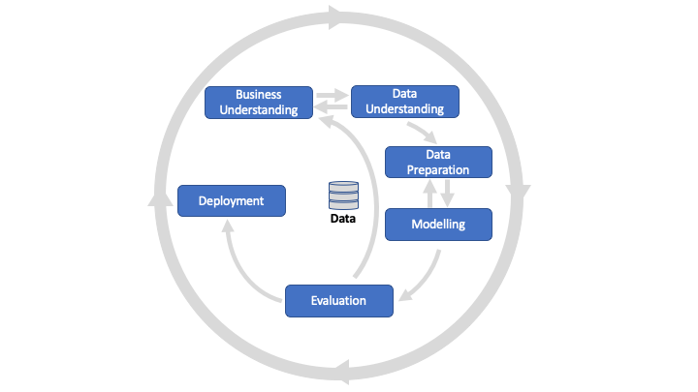

*Figure 1: CRISP Project Management approach*

There are alternatives to this approach, which will be elaborated on in Data Science workshops, but they share the characteristic of stepwise systematic approach.

The relation between CMGT production stages and CRISP Project management stages is displayed in the figure 2.

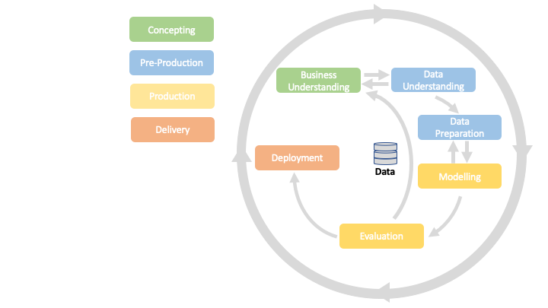

*Figure 2: CRISP and CMGT production stages*

In each block period we focus on a (set of) stages in the CRISP approach. For Block A these are the “Concepting” competencies:

### Competency **4:** Investigate & Analyse

The starter professional practitioner is capable of substantiating a design assignment by means of research and analysis. The starting professional practitioner demonstrates in his/her research activities that he/she has a repertoire of relevant research skills and is able to select the correct method from this repertoire, given the research circumstances. Is capable of developing prototypes as a means of communication within the context of the application.

Dublin Descriptors: Knowledge & Insight, Application of Knowledge & Insight, Making Judgements

### Competency **5:** Conceptualizing

The starter professional practitioner demonstrates he/she is capable of achieving a realistic cross-sector demand articulation and project definition. He/she is capable of developing, on the basis of his/her own idea or demand articulation, an innovative concept which creates value.

Dublin Descriptors: Knowledge & Insight, application of knowledge & Insight, Making Judgements.

Both of these competencies are assessed on hbo-level 1 (see student handbook, page 11 for further explanation): Simple, structured, applies known methods directly according to specific norms, in a simple context, with guided supervision.

Within the CRISP approach, these is the stage highlighted below.

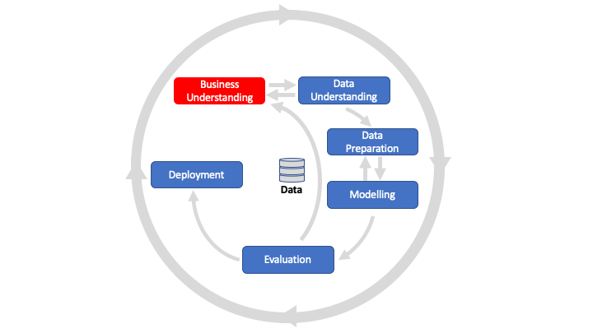

*Figure 3: Focus in Block A*

The Dublin-descriptors referred to are agreed on at an EU level to demark the bachelor education level. These form the justification for handing out a bachelor degree after you finish the program.

## Learning Outcomes

The competencies mentioned in the previous section (competency 4 and 5) and personal development, academic practice and professional practice learning objectives have been translated into intended learning outcomes for Block A in the first year:

### Personal Development & Academic Practice

The student demonstrates self-exploration and personal development, good academic practices in learning how to learn and the acquisition of professional knowledge through research, study, analysis, applied practice, discussion and reporting.

For block A of the first year this is operationalised as:

1. The student sets ambitious, S.M.A.R.T. goals in alignment with the project brief, their chosen role(s), and their personal long-term goals.
2. 1.4 Reports on learning progress and updates plans in a well-written, concise format with appropriate visual communication, guided by active engagement with feedback.

These learning outcomes can be evidenced by:

* The learning Log - Section A
* The weekly goals from Worklog / Section B

### Professional Practice

The student demonstrates professional behaviour as well as accountability and ethics in the application of industry best practices for planning, communication, collaboration, and responsible execution of work assignments.

For block A of the first year this is operationalised as:

The student creates and updates plans to work effectively based on agreed upon priorities with consideration of dependencies and risk, using sound estimates to achieve short and long-term objectives.

This learning outcome can be achieved by executing what is written in the assignments in the three creative briefs.

### Artificial Intelligence and Digital Transformation

The student demonstrates basic knowledge about the field of AI by examining its foundational concepts and methods and evaluating current cases in which AI is applied to transform companies by means of an effective (informative, readable, clear) report. This comprises of:

1. The student Identifies, and analyzes AI applications in fictional and business scenarios by examining and applying relevant concepts from AI literature and theory by means of a report.
2. The student recognizing opportunities and threats in applying AI to transform existing businesses.

### Data Science

The student demonstrates a full understanding of different data types, descriptive data, graphical representations of data, statistical inference, basic probability theory, correlation and simple linear regression by solving appropriate use-cases. The student is able to utilize different data visualization methods available and choose the appropriate graphical representation to gain insight from data and interpret the visualisations appropriately and report results in an insightful manner. This comprises of:

1. Students demonstrate an understanding of foundational concepts in data science and R programming.
2. Students apply the data science concepts learned and use a standard data science tool to solve a project task.

### Programming

The student demonstrates a basic understanding of python programming concepts, data types and data structures and applies learnt concepts and with the usage of standard python libraries to solve a image processing project. This comprises of:

1. Students develop a basic understanding of python programming concepts, data types and data structures.
2. Students apply the programming concepts learned and use standard data science libraries to solve a project task.

Evidence of ILOs III to V is delivered via the final report of the DataLab project.

Assessment indicators for each of these intended learning outcomes can be found in the assessment slide, as well as the weight of each ILO in the final assessment. The knowledge and skills you need to produce the evidence requested is delivered via Github classroom.

## (Formative) feedback

A block is organized cyclically in the Project Loop:

* At the start of a block students project **goals** based on the project brief and previous results.
* At the start of the week students (**reflect** on lessons learned and) **plan** their work for the week
* On a daily basis they **develop** work and **review** that work with peers and lecturers.
* At the end of the block students are assessed based on the learning evidence.

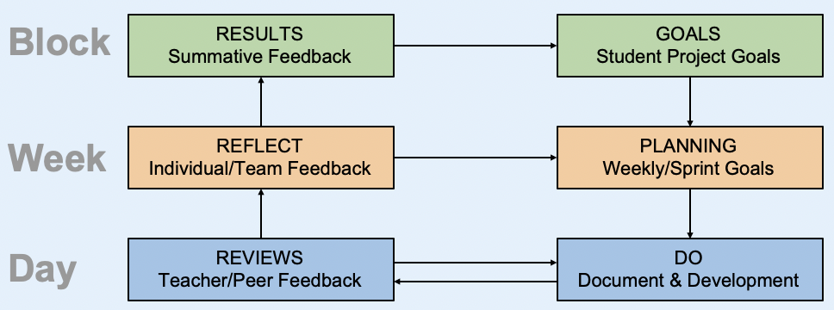

*Figure 4: Project loop*

The Project Loop shows how important feedback is at all 3 levels. Feedback comes in various forms. It may be:

* + On your weekly reflections in a Learning Log review with a lecturer
  + From a teammate during Datalab, peer review or mentor group session
  + From asset reviews (code review, portfolio reviews, etc.)
  + From an external or other form of learning community

Pro-actively seeking various types of feedback, and using it to learn and improve your work, is a critical skill and is part of the Professional Development ILO of every block.

During the DataLab days every two weeks there will be an individual (formative) feedback session for each student. Formative feedback is feedback to help students improve the quality of the work. On the Friday of week 2, 4 and 6 a 30 minutes one-on-one session with a member of staff will be scheduled, in which students demonstrate their progress, reflect on their learning skills and receive suggestions for improvement.

## Assessment and summative feedback

At the end of the project every student is individually assessed based on the project’s ILOs by a team of lecturers. Assessment will take all evidence into account, but focuses on the Learning Log as core document. Other evidence looked at are your portfolio, work logs, team reviews and supporting evidence added to your assignment in Teams/Github. Students are strongly advised to self-assess as well, so as to align mutual understanding of learning and progress.

You are requested to deliver:

* Your portfolio;
* Your Learning Log;
* Your Work Log;
* Your self-assessment-form.

Two members of staff will assess your work. See section 1.4 of this project brief for the exact dates.

## Retake procedure

Each academic year you are entitled to **a maximum of 2 opportunities** to successfully complete the requirements for a Block. For the first opportunity you will be signed up automatically. **For the second opportunity (a retake) you do need to register.**

The retake assessment submission deadline is the same as the normal project deadlines and will be assessed at the same time. You can take advantage of the retake moment at any point during the year. For example, if you have failed the first opportunity of Block A, then you have until the end of week 8 in Block B, C, or D to submit your retake for Block A.

You can inform the teaching team that you are ready to be reassessed by signing up for the second opportunity in Osiris: <https://osiris.buas.nl/>. Your retake will be assessed at the end of the block in which you signed up. The retake deadline is the same as the deadline of the normal project that runs that block. **Only sign up for retake in case you need it and your evidence is ready**. You need to complete and hand-in the retake assignment in Teams as described in this video: <https://web.microsoftstream.com/video/78581dd3-a7e1-4ead-bd82-8fc41b5d19ec>.

For 1st years, you are expected to take your retake opportunity in the following block - so failing Block A means you should be retaking this in Block B, and so on. Note that it is extremely difficult to recover if the failure is due to a significant shortage of work / evidence. I.e. if you fall more than a week behind - for whatever reason. Please inform the study coach and teaching staff immediately if you start to fall behind, and we will help you get back on track. Do not wait until the end of the block!

**Please be aware you can start on the retake when you want, preferably from the start of the next block. This will allow time to collect feedback from teachers and get yourself ready in time for the deadline.** Year 1 students are encouraged to submit the retake for a project they failed the next block after to avoid staggering retakes towards the end of the year. If you are redoing a year and joining the same project again you will need to sign up for the first opportunity that year as well since in this case it is seen as a retake.

A third opportunity is exemptional. If you need a third opportunity this needs to be requested with the Board of Examiners

**IMPORTANT:**

* + When you have multiple retakes or redoing a year discuss your progress with your Study coach.
  + Always sign up for any form of a retake

# 2. Creative Brief I - Report on AI in Science Fiction

## 2.1 Timeline

* S.M.A.R.T. workshop (goal setting workshop)
* planning/ priority skills training
* time management training
* making a study plan training

### Week 1

|  |  |  |  |  |  |  |  |
| --- | --- | --- | --- | --- | --- | --- | --- |
| Day/Time | 9-10 | 10-11 | 11-12 | 13-14 | 14-15 | 15-16 | 16-17 |
| Monday | Foundations of AI (1): Philosophy, and history of AI  Turing Test & Chatbots (1): Article and chatbots | | | | | | Q&A and day recap |
| Tuesday | AI in Science Fiction (1): Minority Report screening  Turing Test & Chatbots (2): Discussion and experiment | | | | | | Day reflection |
| Wednesday | Reporting: The structure of a paragraph and rules of writing  Citations and bias-free language  Mechanics of style of effective writing | | | | | | Q&A and day recap |
| Thursday | Foundations of AI (2): Symbolic/non-symbolic AI &  Intelligent agents | | | | | | Q&A and day recap |
| Friday | AI in Science Fiction (2): Formative feedback session on first draft | | | | | | Day reflection |

### Week 2

|  |  |  |  |  |  |  |  |
| --- | --- | --- | --- | --- | --- | --- | --- |
| Day/Time | 9-10 | 10-11 | 11-12 | 13-14 | 14-15 | 15-16 | 16-17 |
| Monday | AI for Business (1): Introduction into application of AI in businesses  & Risks and benefits of AI | | | | | | Q&A and day recap |
| Tuesday | AI in Science Fiction (3): Q&A session on the final report | | | | | | Day reflection |
| Wednesday | AI for Business (2): Application of AI in businesses A | | | | | | Q&A and day recap |
| Thursday | AI for Business (3): Application of AI in businesses | | | | | | Q&A and day recap |
| Friday | AI in Science Fiction (4): Q&A session on the final report  Formative feedback session I | | | | | | Day reflection |

## 2.2 Assignment

Students are required to create a professional report of maximum 2000 words (excl. cover/table of content/list of references and appendices) on AI and Science Fiction using academic style of writing. For the report, students are expected to analyse Minority Report, which is a movie that uses AI as an integral part of the plot.

In the report, the student must describe the plot and the role played by AI; identify, as well as describe an AI topic, and subsequently assess its feasibility. Additionally, the report needs to contain one case of how this, or a similar AI topic as in the movie is being implemented in a business setting.

Furthermore, the student needs to find a company that has a business challenge that could (partially) be solved by applying AI technology. The challenge needs to be explained and the AI technology should contribute to the solution of the problem. Lastly, the risks and benefits associated with this specific AI application need to be identified and defined.



Figure 4: Minority Report (Spielberg, 2002)

## 2.3 Requirements

2.3.1 Content and professional skills

* Identify, describe and analyse an AI topic within the movie Minority Report;
* Evaluate the feasibility of the AI topic and explain how this AI topic or a similar AI topic is being implemented within a specific business setting;
* Find a business that has a challenge and explain how the AI topic could be deployed to (partially) solve this business challenge;
* List and define at least one benefit, as well as one risk associated with the AI business application;
* Support an argument by providing evidence found in relevant (academic) literature and theory;
* Effectively read and summarize literature;
* Evaluate the credibility of sources (for guidelines, see Buttram et al., November 2012);
* Develop an argument, and subsequently support it with evidence found in credible and relevant literature and theory.

### 2.3.2 Rules of writing requirements

**LEVEL 3 (MINIMUM) REQUIREMENTS**

* Maximum 2000 words (excl. cover/table of content/list of references and appendices
* Correct spelling;
* Page formatting is according to APA 7th Edition;
* The report doesn’t contain any bias-free language;
* The report is written using UK English;

**LEVEL 4 REQUIREMENTS**

* Appropriate punctuation;
* The report is written formally, without clichés, jargon, impersonally;
* The citations and references in the report should follow guidelines of APA 7th Edition;

**LEVEL 5 REQUIREMENTS**

* The report is written according to mechanics of style of effective writing mentioned in the 7th edition of the APA Publication Manual;
* The report is structured based on the criteria’s mentioned in the 7th edition of the  book APA Publication Manual and Rules and Conventions of Academic Writing by Hall (2013).

**2.4 Challenge**

You are encouraged to get the best out of yourself. Therefore, within the AI&DM programme, we regularly give you the opportunity to push yourself further by giving you so called bronze-silver-gold challenges. By achieving these you can earn badges, that mark excellent students.

## 2.5 Deliverable(s)

Report on AI and Science Fiction

## 2.6 Required literature

* American Psychological Association. (2020). *Publication manual of the American Psychological Association* (7th ed.)
* Buttram, C., MacMillan III, D., & Thompson, T. (2012, November). *Source Credibility: How To Select The Best Sources*. University of North Alabama Center for Writing Excellence. [https://www.una.edu/writingcenter/docs/Writing-](https://www.una.edu/writingcenter/docs/Writing-Resources/Source%20Credibility.pdf)Resources/Source%20Credibility.pdf
* Diaz, L. (2014, May). *How to Take Notes of Videos. USC Kortschak Center for Learning and Creativity.*
* <http://kortschakcenter.usc.edu/wp-content/uploads/2014/05/Video-Note-taking.pdf>
* Keshav, S. (2007). *How to read a paper. ACM SIGCOMM Computer Communication Review, 37(3), 83-84.*
* Maar, B., Ward M. (2019). *Artificial Intelligence in Practice. How 50 successful companies used artificial intelligence to solve problems.* Wiley
* Rouhiainen, L. (2018). *Artificial Intelligence: 101 things you must know today about our future.* Lasse Rouhiainen.
* Spielberg, S. (Director). (2002). *Minority Report [Film].* Twentieth Century Fox.
* Stuart, R., & Peter, N. (2020). *Artificial Intelligence: A Modern Approach.*
* Turing, A. M. (2009). *Computing machinery and intelligence. In Parsing the Turing test (pp. 23-65).* Springer, Dordrecht.
* Hall, H. (2013). *Rules and Conventions of Academic Writing by Hall.* <https://drhazelhall.files.wordpress.com/2013/01/2013_hall_rules-conventions_ac_writing.pdf>

# Creative Brief II – Poster: Our world in data

## Timeline

### Week 3

|  |  |  |  |  |  |  |  |
| --- | --- | --- | --- | --- | --- | --- | --- |
| Day/Time | 9-10 | 10-11 | 11-12 | 13-14 | 14-15 | 15-16 | 16-17 |
| Monday | 1. Introduction to DS (seeing the world in data, attributes) 2. Online Interactive Workshop and introduction to R using swirl. 3. Online Interactive Mock Assessment | | | | | | Q&A and day recap |
| Tuesday | DataLab 00: Introduction.  Choose SDG indicator (<https://sdg-tracker.org/> ), create problem statement and setup introduction | | | | | | Day reflection |
| Wednesday | 1. Variables (data frames, continuous, nominal, ordinal etc.) 2. Online Interactive Workshop 3. Online Interactive Mock Assessment | | | | | | Q&A and day recap |
| Thursday | 1. Descriptive analyses (mean, sd, range, IQR) & visualisation (boxplots) 2. Online Interactive Workshop 3. Online Interactive Mock Assessment | | | | | | Q&A and day recap |
| Friday | DataLab 01: Exploratory Data Analyses (EDA) Methodology  Identify and download the relevant SDG variables. Import the dataset and packages. Plan and perform an exploratory data analysis and report your methodology. | | | | | | Day reflection |

### Week 4

|  |  |  |  |  |  |  |  |
| --- | --- | --- | --- | --- | --- | --- | --- |
| Day/Time | 9-10 | 10-11 | 11-12 | 13-14 | 14-15 | 15-16 | 16-17 |
| Monday | 1. Introduction to Probability (random variable, distributions) 2. Online Interactive Workshop 3. Online Interactive Mock Assessment | | | | | | Q&A and day recap |
| Tuesday | DataLab 02: Findings  Create informative descriptive data visualisations from your EDA. | | | | | | Day reflection |
| Wednesday | 1. Introduction to stat. inference (sample, pop, hypothesis testing) 2. Online Interactive Workshop 3. Online Interactive Mock Assessment  B | | | | | | Q&A and day recap |
| Thursday | 1. Analysing Relationships between variables (e.g., compute correlation by hand) 2. Online Interactive Workshop 3. Online Interactive Mock Assessment | | | | | | Q&A and day recap |
| Friday | DataLab 03: Discussion  Identify and write up the interpretation considerations regarding the data and make recommendations for future analyses and data driven decisions.  Formative feedback session II | | | | | | Day reflection |

### Week 5

|  |  |  |  |  |  |  |  |
| --- | --- | --- | --- | --- | --- | --- | --- |
| Day/Time | 9-10 | 10-11 | 11-12 | 13-14 | 14-15 | 15-16 | 16-17 |
| Monday | 1. Reporting & visualising (Academic Skills) 2. Online Interactive Workshop 3. Online Interactive Mock Assessment | | | | | | Q&A and day recap |
| Tuesday | DataLab 04: Conclusion  Summarize the problems statement, research questions, what the data implications were for these and how to proceed. Potential references. | | | | | | Day reflection |
| Wednesday | 1. Introduction to regression & machine learning (supervised, unsup..., the CRISP DM model) 2. Online Interactive Workshop (short) 3. Online Interactive Mock Assessment (short) 4. Working on creative brief poster | | | | | | Q&A and day recap |
| Thursday | 1. Data Science Block A recap 2. Working on creative brief poster 3. Deadline at 17:00 | | | | | | Q&A and day recap |
| Friday | DataLab 05:  Poster presentation day  Peer reviewed Poster Assessment. | | | | | | Day reflection |

## Assignment: Poster-Our world in data

In order to change the world, we must first be able to measure it. Measuring and quantifying what matters is a key component of evaluating progress. In September 2015, all countries of the world agreed to adopt certain goals as targets or indicators for global development. Collectively, these goals are known as the United Nations Sustainable Development Goals (SDGs). In this assignment, you are tasked with evaluating and describing [**our world in data**](https://ourworldindata.org/), investigating how the world is performing on its sustainable development goals.

In this assignment, you will create a poster communicating the results of your investigation.

Figure 5: The United Nations Sustainable Development Goals.

Students are expected to adhere to a data science lifecycle process flow (see Figure 6).

The stages of the project (which will be distributed across the data lab days) are:

1. **Define a data-driven research question.**

Students are expected to frame a data-driven related research question related to a sustainable development goal. A question which can be answered based on data-driven arguments is a data-driven research question. Questions can range from simple (e.g., how country X is performing on indicator Y) to complex (e.g., how country X is performing on indicator Y and what are they key variables related to Y). Use [SDGTracker](https://sdg-tracker.org/) to help formulate your problem statement.

1. **Gather the appropriate dataset.**

Students are expected to use the sustainable development goals data bank in order to gather the appropriate dataset to answer their research question. Use [SDGDataBank](https://ourworldindata.org/sdg-tracker-update) to gather the appropriate dataset.

1. **Explore your dataset.**

Students are expected to apply the exploratory data analysis (EDA) concepts learned in the workshops to their datasets.

1. **Analyze your data and present your findings using visuals.**

Students are expected to apply concepts learned in the workshops and generate appropriate visuals which help support their arguments towards answering their research question.

1. **Provide a solution to your research question with supporting arguments (based on your analysis)**

Students are expected to answer their research question with supporting arguments based on the work conducted in the previous data labs. Further, students are expected to summarize their analysis in the form a poster.

1. **Poster Presentation Day**

Students are expected to present their poster to staff and peers in a poster session. Students and staff will be allowed to vote for the best poster.

Figure 6: Project Lifecycle

## Challenges

## Requirements

* For a more detailed explanation of expected contents of the posters; and an example of a data science poster template: [**DS1-AssesmentPoster_Template.pptx**](https://edubuas.sharepoint.com/sites/DevTeamAAIDM/_layouts/15/Doc.aspx?OR=teams&action=edit&sourcedoc=%7b217F0ADE-5F00-4ADB-B45E-CF4F75175AE5%7d)
* There are no explicit style requirements, but please adhere to good practices. See [Making a better research poster - YouTube](https://www.youtube.com/watch?v=AwMFhyH7_5g) for an example of good practises to follow.

## Deliverable(s)

The posters are to be handed in Microsoft Teams no later than 5pm on the day before the session in which we present the posters. There is no specified file format or size for handing in your poster but confer with a lecturer beforehand if you're handing in something other than PowerPoint, PDF or word to make sure they can actually open the file.

# Creative Brief III – Image Steganography using Python

## Timeline

### Week 6

|  |  |  |  |  |  |  |  |
| --- | --- | --- | --- | --- | --- | --- | --- |
| Day/Time | 9-10 | 10-11 | 11-12 | 13-14 | 14-15 | 15-16 | 16-17 |
| Monday | Fundamentals of programming | | | IDE setup and introduction to Python | | | Q&A and day recap |
| Tuesday | Foundation exercises with Python using jupyter notebooks C | | | | | | Day reflection |
| Wednesday | Data types | | | Data structures - I | | | Q&A and day recap |
| Thursday | Getting started with Pandas - I | | | Getting started with Pandas - II | | | Q&A and day recap |
| Friday | Basic data wrangling with standard file formats  Formative feedback session III | | | | | | Day reflection |

### Week 7

|  |  |  |  |  |  |  |  |
| --- | --- | --- | --- | --- | --- | --- | --- |
| Day/Time | 9-10 | 10-11 | 11-12 | 13-14 | 14-15 | 15-16 | 16-17 |
| Monday | Data structures - II | | | NumPy | | | Q&A and day recap |
| Tuesday | Image Processing using standard python libraries | | | | | | Day reflection |
| Wednesday | Bit/Logical operators | | | Vectorised code in Python | | | Q&A and day recap |
| Thursday | Introduction to visualization libraries in Python | | | Introduction to modelling libraries in Python | | | Q&A and day recap |
| Friday | Image Steganography - I | | | | | | Day reflection |

### Week 8

|  |  |  |  |  |  |  |  |  |
| --- | --- | --- | --- | --- | --- | --- | --- | --- |
| Day/Time | 9-10 | 10-11 | 11-12 | | 13-14 | 14-15 | 15-16 | 16-17 |
| Monday | Self-Study: PEP 8 – Coding standards for Python | | | Assignments: Python for Data Analysis | | | | Q&A and day recap |
| Tuesday | Image Steganography – II | | | | | | | Day reflection |
| Wednesday | Self-Study: Pandas, NumPy, Matplotlib, Scikit-learn | | | Assignments: Python for Data Analysis | | | | Q&A and day recap |
| Thursday | Application development - I | | | Application development - II | | | | Q&A and day recap |
| Friday | Image Steganography - III | | | | | | | Day reflection |

## Assignment

Steganography is a technique by which information is concealed in plain sight. There are many ways to conceal information. One of the most common techniques is to embed information (text, images, sound) in images. A commonly used method for image steganography the least significant bit (LSB) method. One of the key advantages of encoding information in the least significant bit is that the human eye cannot distinguish between the original image and the image with secret information embedded in it.

In this assignment, you will develop a steganography algorithm which can conceal secret information in an image.



Figure 5: Embedding information in the Mona Lisa

## Challenges

## Requirements

* Only use standard python libraries such as Pandas, Scikit_learn, NumPy and Matplot-lib. In particular, NumPy to manipulate the image and Matplot-lib to display the final image.
* Your code must consist of an encoder function (to embed the secret message) and a decoder function (to decode the secret message).
* Code must be well formatted and commented. Use the PEP8 style guide.
* At time of submission, code should compile with no errors.
* Use Github for version control.
* Use Jupyter notebooks.
* <https://medium.com/analytics-vidhya/shh-your-secret-is-safe-a-simple-guide-to-steganography-in-python-89116582277e>
* <https://github.com/kelvins/steganography>
* <https://www.oreilly.com/library/view/programming-computer-vision/9781449341916/ch01.html>

## Deliverable(s)

The Jupyter notebooks are to be uploaded to Github no later than 5pm on last data lab day. Confer with a lecturer beforehand if you're handing in something other than Jupyter notebook.